Lab No. 02

1. Import Necessary Python Libraries
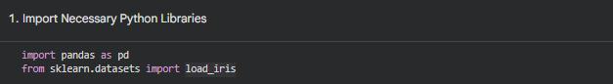
2. Read Iris Dataset from Scikit-Learn
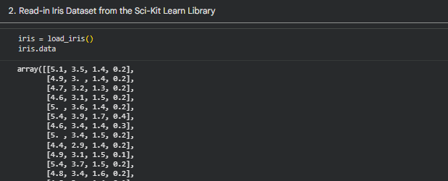
3. Make DataFrame from Dataset
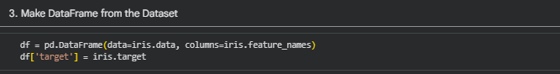
4. Display First Five Data Samples
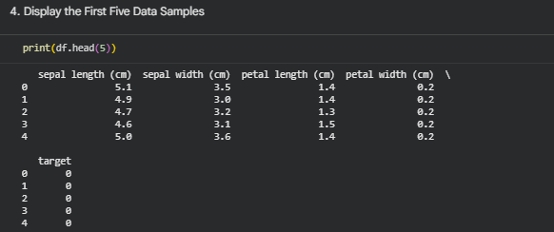

5. Show Last Five Records
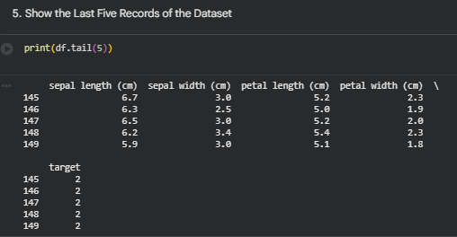
6. Rename Columns
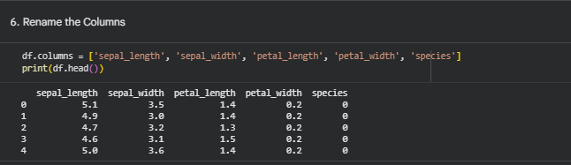
7. Basic Information About DataFrame
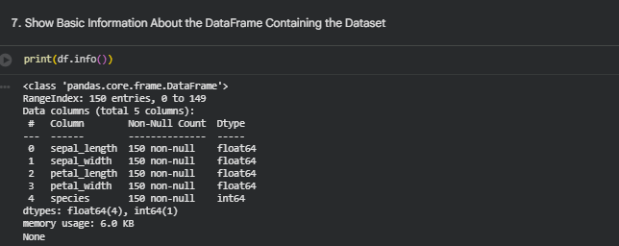

8. Explore Schema of DataFrame
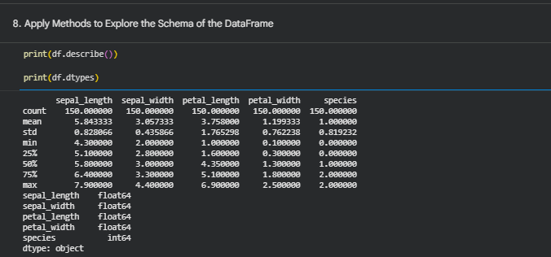
9. Access Independent Variables & Explore Types/Frequencies
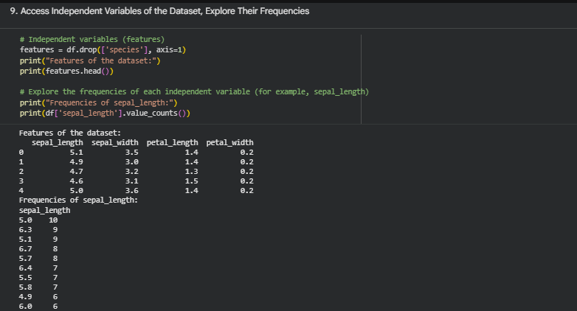
10. Standard Deviation, Min, Max of Each Feature
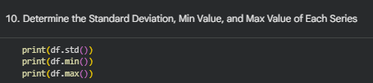
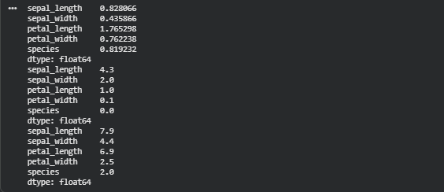
11. Sort Dataset Based on Features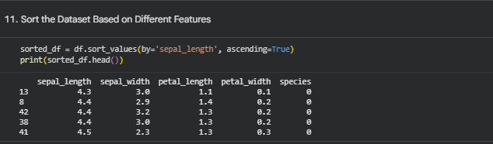12. DataFrame Slicing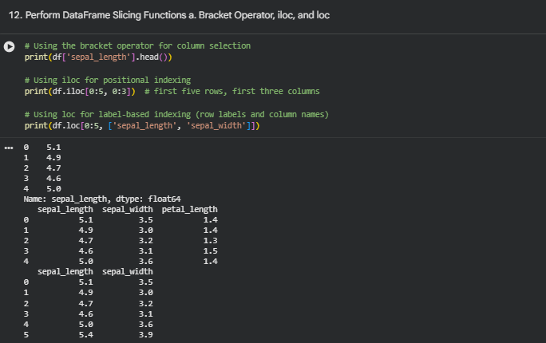
13. Find Unique Values in a Series
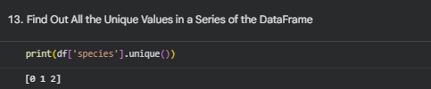
14. Total Number of Unique Values
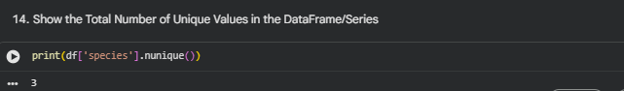

15. Range of Values for Each Feature
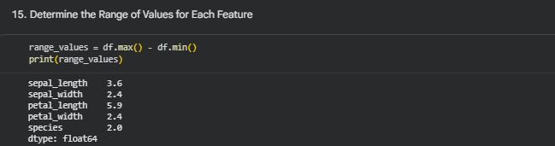
Tasks
